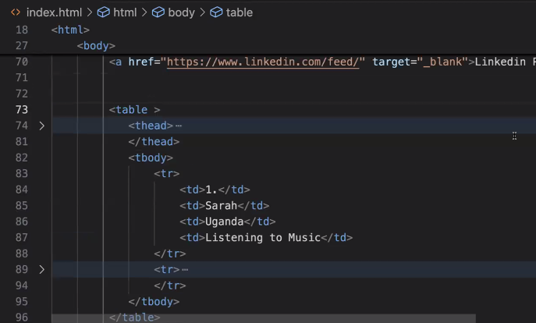

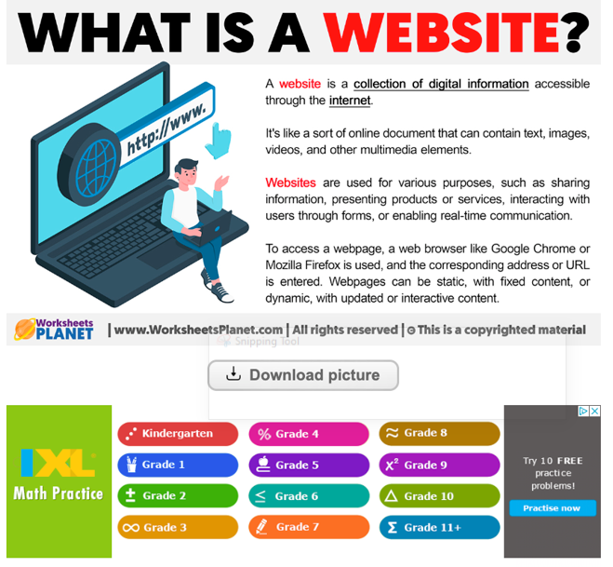

<!-- HTML - HyperText Markup Language - give structure to content on our web page.

tags and element

attribute

semantic tags

-tags - code to define and element - <> </>

- element - what you use for a specific task - includes the <> and </>, content

<html></html>

<p></p>

-self-closing tag - < /> < >

<img src="" alt="" >

<img src="" alt="" /> -->

<!-- comment here -->

<!DOCTYPE html>

<html>

<head>

<meta name="viewport" content="width=device-width">

<meta name="author" content="Femi">

<meta name="description" content="WIT HTML Class">

<meta charset="UTF-8">

<title> First HTML class</title>

<link href="#" rel="">

</head>

<body>

<!-- content for your page -->

<!-- <div style="background-color: blue;">

hello one

</div>

<div style="background-color: green;">

hello two

</div>

<span style="background-color: blueviolet;">Span one</span>

<span style="background-color: rgb(102, 167, 6);">Span one</span> -->

<!-- <p>My name is <span style="color: green">Femi</span></p> -->

<!-- <div>

<header>

This is a header tag

</header>

<h1>WIT H1</h1>

<h2>WIT H2</h2>

<h3>WIT H3</h3>

<h4>WIT H4</h4>

<h5>WIT H5</h5>

<h6>WIT H6</h6>

<p>This is a paragraph and you use it for text purpose</p> -->

<!-- list

-ordered list - ol

-unordered list - ul

-->

<!-- <p>List of Students</p>

<ul>

<li>Faranak</li>

<li>Amrita</li>

<li>Ellie</li>

<li>Cindy</li>

<li>Hyejin</li>

</ul>

<p>List of Courses</p>

<ol type="I">

<li>Scratch</li>

<li>Python</li>

<li>HTML</li>

<li>CSS</li>

</ol>

</div>

<a href="https://www.linkedin.com/feed/" target="_blank">Linkedin Profile</a>

<table border="1">

<thead>

<tr>

<th>S/N</th>

<th>Name</th>

<th>Country</th>

<th>Hobby</th>

</tr>

</thead>

<tbody>

<tr>

<td>1.</td>

<td>Sarah</td>

<td>Uganda</td>

<td>Listening to Music</td>

</tr>

<tr>

<td>2.</td>

<td>Olesia</td>

<td>Canada</td>

<td>Hiking</td>

</tr>

</tbody>

<tfoot>

<tr>

<td>total</td>

<td>North America</td>

<td>26 students</td>

<td>Introvert</td>

</tr>

</tfoot>

</table> -->

<!-- forms -->

<form action="/login" method="post">

<div>

<label for="firstname">Name:</label>

<input type="text" id="firstname">

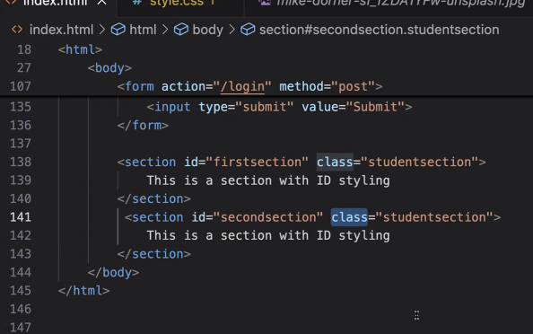

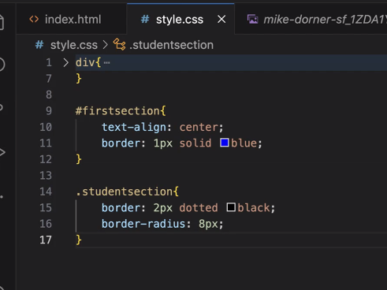

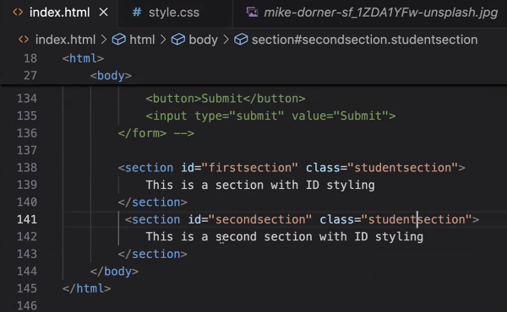

</div>

<div>

<label>Python:</label>

<input type="checkbox">

</div>

<div>

<label>Javascript:</label>

<input type="checkbox">

</div>

<div>

<label>HTML:</label>

<input type="checkbox">

</div>

<div>

<label>Yes:</label>

<input type="radio" id="yesoption" name="diet-options">

</div>

<div>

<label>No:</label>

<input type="radio" id="nooption" name="diet-options">

</div>

<button>Submit</button>

<input type="submit" value="Submit">

</form>

</body>

</html>